***2019 Alliance Board of Directors***

Eileen Cavanaugh was appointed as President & CEO of the Boys & Girls Club of Greater Holyoke in September 2010. Eileen oversees 5 sites in the City of Holyoke serving over 350 youth daily. She is a MA state certified elementary teacher and has worked in the field of after-school and out-of-school-time for over 20 years having developed extensive experience in the development of programs aimed at children, teens, and families. Eileen is a recent graduate of the Boys & Girls Club of America Leadership Summit. A mastery level program designed and facilitated by Harvard Business School for Boys & Girls Club professionals. For the last 3 years, Eileen has been involved with the MA Alliance of Boys & Girls Club acting as Vice President, interim Treasurer most recently as President.

For the past three years, Derek Heim has been the President & CEO of the Boys & Girls Club of Brockton. In late 2017, he additionally assumed the role of Interim CEO of the Boys & Girls Club of Taunton where the organizations today are sharing best practices, partnerships, and resources. The Clubs are in joint pursuit of opportunities to broaden the scope and reach of core after-school, weekend, and summer camp programs. Prior to his most recent work with Clubs, Derek spent ten years in the YMCA movement in the South Coast of Massachusetts where his work was nationally recognized by his peers in social responsibility, child protection, and youth initiatives. Derek is an elected Selectman in his hometown of Swansea and works closely with both local and state political leaders in advancing causes for his community and the Commonwealth. Derek is also the 2018 Northeast Vision Spirit Award recipient, presented at the regional conference of Boys & Girls Clubs of America. Derek has been involved with the MA Alliance of Boys & Girls Clubs acting as Vice President.

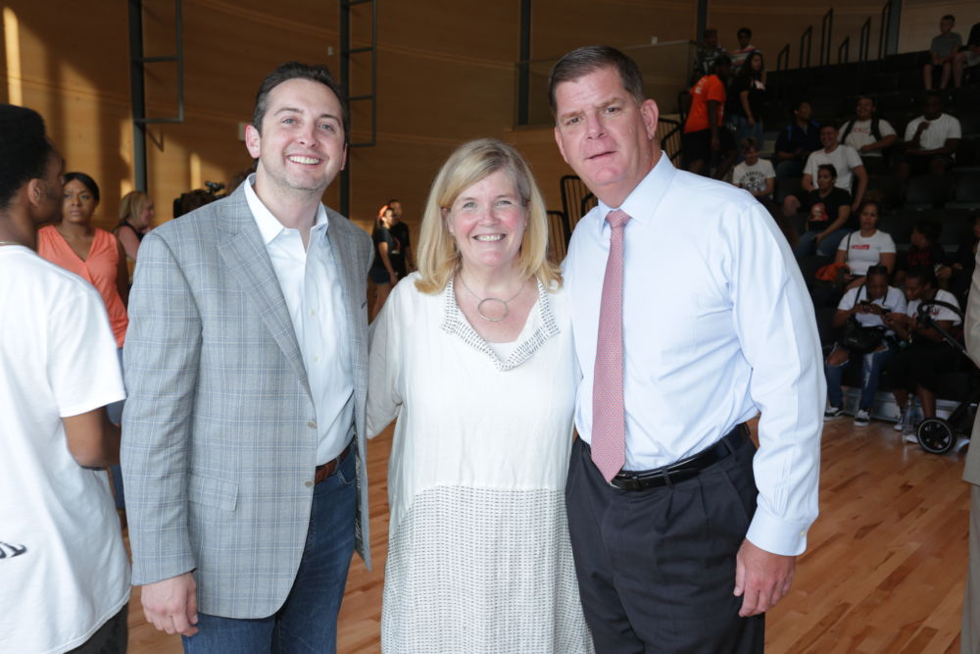Andrea began her career in 1988 working at the Boys Club in Mobile, Alabama. Having recently graduated from Boston College, she arrived in Mobile through the Jesuit Volunteer Corps and was assigned to coordinate the “Service to Girls Pilot” – a successful initiative that helped contribute to the organization’s decision to fully welcome girls into the Club. Andrea worked in various positions at the Club and after being selected as a BGCA Woodruff Fellow, she earned her MPA at the University of South Alabama. Andrea went on to work at Clubs in Southern California and Vermont, before accepting the role of founding executive director of the Boys & Girls Clubs of St. Lucie County Florida in 1994. In five years, the organization grew to include 3 neighborhood based sites and 10 school sites in the communities of Port St. Lucie and Fort Pierce. In addition to her work on the local level, Andrea supported the BGC community through her involvement on regional and national conference committees, program design workgroups and also served on the national board of The Professional Association from 1995-1999. In 1999, Andrea returned home to serve as the executive director of the West End House – an independent Boys & Girls Club in the city of Boston. In the last 19+ years, Andrea has worked in partnership with her board and team of outstanding youth development professionals to revitalize this 111 year old organization that in 1998 was slated to be dissolved. Going into her 20th year of service, Andrea is engaged in the largest fundraising challenge of her career – the Expect More Campaign which has raised $22M to date. This campaign has enabled the organization to extend services through college graduation; become the second largest, year-round employer of teens in the city, renovate and expand the facility and strengthen the capital position for a sustainable future. Andrea serves as board member of the Massachusetts Alliance of Boys & Girls Clubs and currently serves on the National advisory committee for the arts at BGCA. In addition, Andrea serves on the board of directors at the Music and Youth Initiative and also serves on the board of advisors for the Eliot School of Fine and Applied Arts.

The five BGCA appointed positions are currently held by:

* Ron Hadorn, Vice President, Northeast Region
* Dana Benjamin-Allen, Director, Product Management
* Susan Taylor, Director or Organization Development, Northeast
* Jason Penegar, Vice President, Controller
* J.R. Kenny, Director, Government Relations, NE; J.R. serves as the Treasurer of the MA Alliance of Boys & Girls Clubs